
The Java Partial-Order-Planner
Sebastian Wells
Supervisor: Peter Andreae

Submitted in partial fulfilment of the requirements for
Bachelor of Science with Honours in Computer Science.

Abstract
This report discusses the implementation of a partial-order-planner in Java. A partial-order-planner is a technique used in Artificial Intelligence that allows agents to autonomously determine a sequence of actions to achieve a task. The algorithm has been developed and improved since its first formal publication under the name of UCPOP, in 1992. It is also frequently taught at university Computer Science courses. However, no attempt has been made to implement the algorithm in Java, even though this would make it more accessible to students and researcher alike. The various issues encountered with an object-orientated implementation are discussed, and two different implementations are described with their respective advantages and limitations.

Acknowledgments
Thanks to my supervisor Peter Andreae for adapting to the pace of a newbie, and friends in Computer Science, Ed, Ben, Vipul, Tsatsat, and particularly Seby for remaining so generous in the face of my persistent inability to make computers go. Seby, I owe you beer. Thinks to America for reminding me there are bigger problems in the world than getting A+s on reports, and Canary, whose fault it will be if I don’t. Finally, thanks to my family, for being the ones that are going to have to read this!

Contents
1 Introduction 1
1.1 Planning 1
1.2 Original Aims 1
1.3 JavaPOP 2
1.4 Project Overview 2
1.5 Report Organization 2
2 Background 3
2.1 State Descriptors 3
2.2 STRIPS Operators 3
2.3 Partial Order Planning 4
2.4 UCPOP 5
2.5 Heuristics 9
3 Implementation 1 10
3.1 Approach 10
3.2 Classes 11
3.3 Binding Mechanism 13
3.4 Binding constraints 15
3.5 Backtracking 16
3.6 Errors and Limitations 17
4 Implementation 2 19
4.1 Why a second implementation was created 19
4.2 Approach 19
4.3 Classes 20
4.3 Binding Mechanism 22
4.4 Binding constraints 23
4.5 Errors and Limitations 23
5 Evaluation 24
5.1 Briefcase World 24
Actions and Objects of the Briefcase domain 24
Task 24
5.2 Cook world 25
Actions and objects of the Cook domain 26
Task 26
5.3 Blocks World 27
Actions and Objects of Block World 27
Task A 28
Task B 29
5.4 Fridge World 30
Actions and Objects of the Fridge domain 30
Task 31
5.5 Monkey World 32
Actions and objects of the Monkey domain 32
Task 32
6 Conclusion 34
Goals reached 34
Future Work 34
Figures
Figure 2.1: An initial plan with start and end actions. 6
Figure 2.2: An instantiated action. 7
Figure 2.3: A detected threat. 7
Figure 2.4: A threat resolved with demotion. 8
Figure 3.1: The important classes of the first version. 12
Figure 3.2: Variable binding within an action. 13
Figure 3.3: Binding during instantiation. 14
Figure 3.4: Reverse binding. 15
Figure 3.5: A binding error. 18
Figure 4.1: The important classes of the second implementation. 21

Chapter 1
Introduction
1.1 Planning
The field of artificial intelligence concerns the development of machines that perform tasks without requiring human assistance, in ways that appear ‘smart’. Planning is an integral part of this research and is behind the development of intelligence in actuated robots, as well as problem solving applications. Planning specifically defines the process where an agent determines a correct sequence of actions, called a plan, to achieve a task assigned it. It is inherently a search through ‘plan-space’ - the collection of all possible plans, to find one that achieves the task. Determining what these possible plans are and how to search through them in an efficient way to locate a valid solution are the problems at the root of the field.
To autonomously generate plans, agents need a way of understanding the current state of the world and the goal state. They also need knowledge of a set of actions to be executed. The planning is then a process of applying and ordering these actions in a way that changes the initial state into the goal state. There have been many techniques developed within the field of Artificial Intelligence for autonomous plan creation. Partial-order-planning is one established technique.
1.2 Original Aims
Create a Java implementation of a partial-order-planner
The primary aim of this project was to successfully create a Java implementation of the partial-order-planning algorithm.
Integrate the planner with a goal hierarchy system
If the planner was completed on schedule, a secondary aim was to then integrate the planner with a goal hierarchy system that was being developed by another student. This system was designed to take a goal and to identify ways in which it could be broken into smaller subgoals. It recursively reduced these subgoals until each could be satisfied with the execution of a single action. This algorithm would fail, however, where it encountered an unexpected state of the world while executing a solution. In this event, a partial-order-planner, with the capacity for problem solving, would be consulted to return a sequence of actions that would change the state of the world in a way that would remove the obstruction.
Create a useful teaching tool
A further aim of the project was to provide a teaching tool which could be used to teach students the partial-order-planner algorithm. Java is an accessible language, and most students have had exposure to it. This makes it the ideal language in which to demonstrate complex algorithms. Presenting a cleanly coded and functional Java partial-order-planner would also allow students to edit the code - rewriting portions or adding improvements.

1.3 JavaPOP
To date, there has been no published attempt to implement a partial-order-planner in Java. This is an unfortunate omission, in that it prevents people without experience in the more specialised languages from being able to understand coded implementations. It also prevents programmers well-versed in Java from being able to submit additions to the body of research on the algorithm.
Object-orientated languages have seen a rise to dominance, particularly in software development and in the student and hobbyist communities. An implementation in Java would provide an opening for these groups into partial-order-planner research. By virtue of being object-orientated, the language allows for the easy appending, removing, and editing of blocks of code. The wide body of algorithms and tools available to Java programmers could finally be experimented with in the context of partial-order-planning. For these reasons, the creation of a Java partial-order-planner (JavaPOP) is an important step in partial-order-planner research.
1.4 Project Overview
This project consists of two parts. The first is the development of an initial version of JavaPOP, which used an approach that allowed easy analysis of the algorithm’s progress and the identification of bugs. This was also a learning and exploratory phase, which identified a number of problems associated with the implementing of a partial-order-planner in an object-orientated language. The focus during this period was to identify the best ways in which to represent the algorithm in Java objects, and to properly grasp the more complex aspects of the algorithm. The version was set aside after inherent faults discouraged further development, though its performance in some problem domains was fault-free. A second approach was then devised that would avoid the issues of the first. This was a fundamentally different execution of the same algorithm. This version avoided problems encountered in the first, but reused a number of the Java objects. The focus for this part was to generate a cleanly written and fully functional program.
1.5 Report Organization
This remainder of this report is organized as follows. Chapter 2 introduces background material necessary for understanding the partial-order-planner algorithm and ways of representing problems. Chapter 3 describes the initial Java implementation. It briefly covers the important Java classes used, and discusses the particular strategy with its limitations and benefits as an initial approach. Chapter 4 covers the second implementation, discussing the reasons why it was written, what advantages it has over the first, and any unresolved problems. Chapter 5 analyses the performances of both implementations on a number of planning tasks, highlighting where the programs are successful and where they fail. Chapter 6 will summarise the degree to which the project achieved its aims and will briefly mention possibilities for further work.

Chapter 2
Background
Before discussing the nature of any implementations, it is first necessary to understand how the algorithm works, and the kinds of problems it solves. This chapter discusses a standard way of presenting problems to a planner and then covers the partial-order-planning technique, mentioning the key features that distinguish it from other planners. It ends by briefly discussing possible improvements to the standard algorithm.
2.1 State Descriptors
A notation is required to describe the state of the world, and the effects of an action on the world. Specific conditions are represented with state descriptors, which are a predicate followed by zero or more variables. For example,
- upright(x)
- on(x, table)
- raining()

For a partial-order-planning problem, these can be used in sets to describe initial and goal states of the world. If so, variables in these state descriptors will be bound to objects in the world.
The argument ‘table’ is an example of a constant. Constants form part of the definition of their containing descriptor, and can not be bound to other elements.
2.2 STRIPS Operators
An implementation of the POP algorithm requires an understanding of STRIPS operators. These provide a way to define actions, and are made up of a word followed by zero or more variables. For example,
- Jump()
- Pickup(x)
- Swap(x, y)

STRIPS operators representing actions are associated with a number of state descriptors that describe their effects on the world. Specifically, an action may remove some conditions in the world state, and it may add others. An action may also require some conditions to be true before it can be performed. A STRIPS operator, therefore, is fully described by three sets of state descriptors that define its requirements for execution, and its effects after execution. E.g.
Pickup(x)
PRECONDITIONS: handempty(), on(x, table)
DELETES: handempty(), on(x, table)
ADDS: holding(x)

Note that if the variable in Pickup(x) is bound to an object, the variable in on(x, table) and holding(x) will be bound in the same way, as they are all the same variable.
The three sets of preconditions, deletions and additions (sometimes deletions and additions are combined into a sinlge effects set) make up the description of an action in a planner. STRIPS operators and their state descriptors need to be established before the execution of a planner, in a way that ensures the problem domain is completely described. The planner is then restricted to the use of these operators when generating plans.
2.3 Partial Order Planning
Creates directed graphs
The POP algorithm differs from conventional planners in that it does not establish a single specific sequence of actions. Where other planners may try appending and removing actions from linear sequences, a partial-order-planner adds actions more loosely to a plan, and defines their position relative to other actions only in saying one must occur somewhere before the other, or vice-versa. An instantiated action does not have a specific predecessor and successor action, but only actions that must precede or succeed it. In this way, a final plan is not a linear solution, but a directed graph of nodes and edges.
Uses a topological sort
A directed graph is not an ideal solution. It is more desirable to have a planner output a linear sequence. To achieve this with a partial-order-planner, a topological sorting algorithm is appended onto the end of the planner’s output. A topological sort traverses a directed graph and determines a way of ordering the nodes into a sequence that is consistent with the graph’s directed edges. The topological sort fails where there are circularities in the graph, e.g. where node-A comes before node-B, node-B comes before node-C, and node-C comes before node-A. Through failing on inconsistent plans, the topological sort can also be used as a tool for checking plan consistencies during development.
Modifies partially complete plans
Progress through the POP algorithm consists of analysing partially complete plans, and modifying them in a way that brings them closer to a solution. A plan is identified as incomplete if there are still subgoals (conditions) that are unsatisfied (untrue). These subgoals may be part of the explicitly defined goal state, or they may be prerequisites of an action that has previously been added to the plan. The progression of a plan may occur through the addition of a new action (a node in the graph), but can also occur in a number of other ways, including the addition of a directed edge.
Executes an AND/OR search
The construction of a plan takes the form of an AND/OR search. The plan-space tree will branch where choices can be made about how to further construct the plan, with each branch representing an option. When moving up through this tree, the algorithm needs to make two types of decisions. AND decisions are where the planner chooses a branch but must at some point choose all branches, and so it is only a question of order. OR decisions define locations where the planner chooses a branch but will only have selected one in the final plan. The selection of a subgoal to be satisfied corresponds to an AND branching. The selection of one of a number of actions that satisfy the subgoal corresponds to an OR branching.
2.4 UCPOP
The UCPOP paper became the accepted standard version of the algorithm on which successive versions built their enhancements [1]. Its description of the algorithm used ADL (Action Description Language), which is more expressive than STRIPS operators. The paper described the logic of the algorithm and proved that it was sound and complete. Because of the difference between ADL and STRIPS, the algorithm included some details that this project has neglected while still producing valid implementations. To aid in understanding this slightly simplified implementation, the UCPOP algorithm will be described below in a form based on STRIPS operators instead of ADL.
Problem definition
A planning problem is defined as two sets of literals (state descriptors), a set of STRIPS operators representing actions, and a world of objects to which variables in the literals can be bound. One set of literals describes the initial state of the world, the other describes the goal state of the world. Each literal in the goal state can be viewed as a subgoal.
Plan definition
A plan can be fully described by four sets of objects:
- Steps
- Links
- Ordering constraints
- Binding constraints
- Open subgoals

Steps, or instantiated actions, are actions that have been included in the plan. Links define the connection of one action to another, where the second action has a subgoal that is satisfied by the first. A link also references the subgoal that is being satisfied. Note that a link does not assert the two action need to be contiguous. Ordering constraints define a required relative position of two actions. It is similar to a link but does not include any subgoal satisfaction. These objects represent the edges in the plan’s graph. Note that an ordering is added to the plan wherever a link is added, on the same actions. They can also, however, be added for other reasons. Binding constraints are a set of possible variable-to-variable or variable-to-object bindings that are not permitted. As variables are bound, this set is checked and if the binding is not permitted, the planner cannot proceed that way. Open subgoals is a collection of state descriptors to be made true before the plan is complete.
Plan initialisation
An initial plan is created to provide a starting point for the algorithm. This plan contains two pseudo-actions that represent the start and end states of the problem. Figure 2.1 shows an example of an initial plan. The ‘start’ action has no PRECONS or DELETES but only an ADDS set of state descriptors, initially true in the world. The ‘end’ action has no ADDS or DELETES but only a set of PRECONS representing conditions that need to be satisfied. An ordering constraint is added to the plan’s set of orderings, defining that ‘start’ must come before ‘end’. The subgoals in ‘end’ are added to the plan’s set of open subgoals.

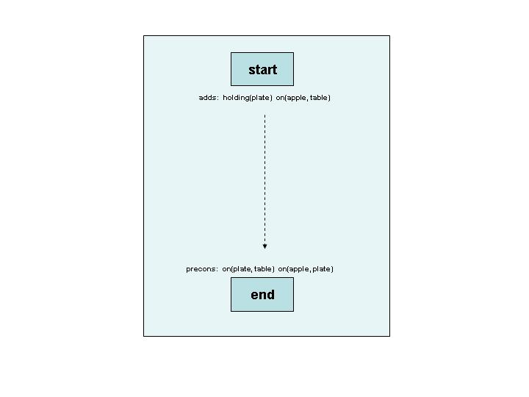

Figure 2.1: An initial plan with start and end actions. The dotted arrow represents an ordering constraint.
Step 1: Subgoal selection
An open subgoal is selected from the set. If there are no subgoals in the set, the plan has succeeded and the plan is returned.
Step 2: Subgoal satisfaction
An action is selected to satisfy the subgoal. This action may either be already instantiated in the plan, or it may be an action described in the problem domain. Actions are identified as possible satisfiers where a literal in their ADDS set corresponds to the subgoal literal. Two literals match where their predicates are the same and their variables can be bound identically without requiring any unbinding. Creating the new connection involves binding the necessary variables and the addition of a link and an ordering constraint. Figure 2.2 shows an action being instantiated to satisfy a precondition of the ‘end’ action. If the satisfying action is not already in the plan’s set of steps, it is added. Any literals in the new action’s PRECONS are added to the plan’s set of open subgoals.

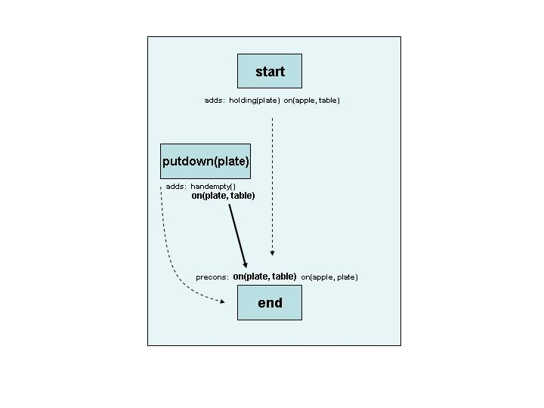

Figure 2.2: An instantiated action. The unbroken arrow represents the new link and the state descriptors involved. The preconditions and deletes fields of the new action have been omitted.
Step 3: Threat detection
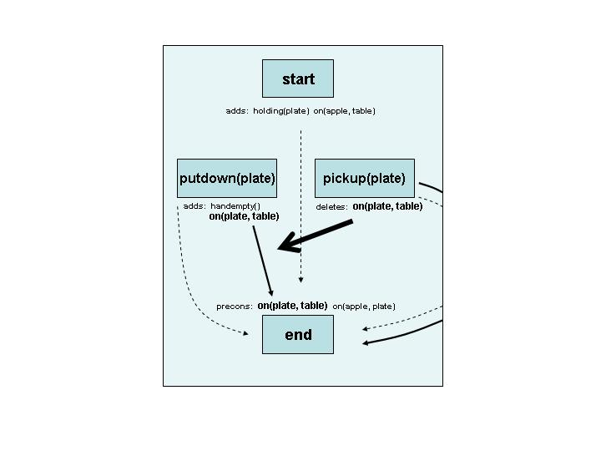
Threat detection (or link protection) is the process where threats to a link are detected elsewhere in the plan. A threat is an action that deletes a condition matching the satisfied subgoal within a link. The placement of this action between the two linked actions would be destructive. All threats of this nature are identified for all links.

Figure 2.3: A detected threat. Pickup(plate) is a previously instantiated action. A state descriptor in this action’s DELETES set threatens the new link.

Step 4: Threat resolution
Threats need to be resolved before a plan can be developed further. Resolving a threat can be done in three ways. If possible, the threat can be demoted. This means enforcing that the action be placed before both actions in the link, by adding an appropriate ordering constraint to the plan. This is shown in Figure 2.4, for the threat described in Figure 2.3. A threat can also be promoted – forced to occur after the link, again by adding an appropriate ordering to the plan. It may not be possible to demote or promote if circularities are generated in the plan’s graph.
The third option for threat resolution is the addition of a binding constraint. A threatening literal may have one or more unbound variables. In this case the threat will only become destructive in the event of the variables being bound in the same way as they are in the subgoal. This can be prevented from happening by adding a binding constraint to the plan.
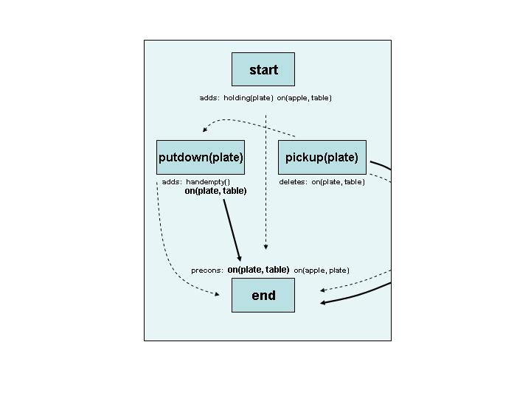

Figure 2.4: A threat resolved with demotion. An ordering constraint is added from the threatening action to the first action in the link.
A plan will only progress if all threats can be resolved without creating circularities in the graph.
Step 5: Recursive call
After successfully resolving threats, the algorithm restarts, making a recursive call and beginning the same sequence of steps on the new plan.
Builds from goal state to initial state
The algorithm constructs a plan starting from the ‘end’ action and moves towards the ‘start’ action. The first actions to be added are those that satisfy one or more of the subgoals of ‘end’. These actions may have their preconditions satisfied by the ‘start’ action, otherwise new actions will need to instantiated. A complete solution will consist of strings of actions linked from ‘end’ to ‘start’, and potentially with links between them.
2.5 Heuristics
Heuristics provide ways of identifying ‘short-cuts’ in searches through the plan-space. Often, we are able to do a lot better than traversing the set of all possible plans blindly. Though the UCPOP paper did not discuss the application of heuristics, many subsequent studies have suggested a number of methods. There are four main areas in the algorithm where heuristics can be used. Below is an outline of some of the possibilities for each area.
Within subgoal selection
Subgoals with bound variables may be selected before subgoals with unbound variables, which would generate shorter strings of bindings and incur less processing time. Subgoals at a closer distance to the ‘end’ action may be selected first [2]. Subgoals that will incur the addition of many more subsequent subgoals may be postponed [3]. This would include selecting subgoals that can be satisfied by instantiated actions before subgoals requiring new actions.
Within threat selection
Threats that involve literals with unbound variables may be postponed, allowing for the possibility that they become bound in harmless ways [4]. Threats that are already resolved through existing orderings can be ignored. The nature of some problems may make the placement of one action type before another impossible, in which case threats depending on that ordering can be ignored [5].
Particularly unnecessary is the repeated identification and resolution of the same threats after every addition to the plan. Preventing resolved threats from being re-identified would be another heuristic.
Within threat resolution
Adding a binding constraint before a promotion or demotion is less likely to cause a plan to fail later through ordering circularities. It is not clear whether this would reduce the number of paths traversed in the plan-space or not.
Within plan selection
Heuristics in this area can only be applied in implementations where many plans are generated and queued. It is possible to create a new plan at every OR branching of the AND/OR tree; for example, creating a plan for every possible action that satisfies a subgoal. Before performing an iteration of the POP algorithm, a plan must then be selected. These could be selected on a FIFO or LIFO basis, corresponding to depth or breadth-first searches respectively. Best-first searches may be implemented if plans are somehow analysed for quality/likelihood of success.
Chapter 3
Implementation 1
3.1 Approach
A single plan
The project's first approach was to design a program that created a single plan, and then modified this plan until it was complete. The single-plan approach was an intuitive initial solution and it allowed the outputting of a readable log of the algorithm’s progress.
Depth-first iterative-deepening search
Using a single plan restricts the way in which an algorithm can search through the plan-space. The modification of a single plan corresponds to traversing a single path in the plan-space tree and is therefore an execution of a depth-first search (DFS). A key issue with DFS is that problem domains allowing circularities in the ordering of actions have infinitely deep plan-spaces.
For example, an action pickup(x) could have a precondition on(x, table). This could be satisfied by an action putdown(x). This action's precondition of holding(x) could then be satisfied by pickup(x). An algorithm implementing a depth-first search would create an unending chain of alternating actions like these, in the absence of some limiting mechanism.
This project restricted the depth of plans by inserting a depth field into the action instances, defining how many actions lie between the instance and the 'end' action. If deeper than some threshold, the algorithm will only use already instantiated actions as possible subgoal satisfiers. Incrementing the threshold from one after each failed completed search implements an iterative deepening search.
Recursive
The entire UCPOP algorithm is executed in a single method. This method makes calls to other methods, but contains the key steps of the algorithm. After the failure of a single AND choice, or the failure of all OR choices, the method returns the failed plan. Failures are established where the method makes a recursive call after attempting an option, and control returns from that call. After a failed call, the attempt at the solution is undone, and the next option tried. A triplet pattern of attempt, recursive-call and undo occurred at the removal of open subgoals for satisfaction, the adding or re-linking of any actions, the removal of a threat for resolution, and the attempting of the three methods of threat resolution.
The success of a plan takes place many recursive calls deep, and so no return is ever made to the sequence of recursive calls before it. The program therefore uses System.exit(0) where a successful plan is reached.
Backtracking requires undoing
The undoing of additions to the plan is a necessary part of the recursive structure. Following any failed recursive call, the plan needs to be reset to its exact state prior to the attempted addition. This is trivial in some cases and more complex in others. Complexities in undoing certain configurations of variable binding were a key factor in the abandonment of this approach. Backtracking will be discussed more fully in a following section.
3.2 Classes
On the following page is a diagram outlining the important classes of the first partial-order-planner implementation. The arrows indicate where the objects were used in the datafields of other objects, though only a few of these relationships are included so as to give a clearer impression of general structure. This diagram, particularly the datafields, should be referred to when reading the remainder of this chapter. Clarifications for some of the less obvious details are below.
State
State descriptors are represented with objects of the abbreviated name ‘State’.
Subgoal
Subgoal objects were written to be used where a reference to the action containing the subgoal was required. This was not possible using only the State object.
Action
A single instance of the Action object is created for each STRIPS operator included in the problem domain, and these are then used as templates. When creating a new action to be instantiated into a plan, a new Action instance is made as a copy off the template.
Variable
This version implements variables as objects with pointers. The pointer datafield is of an undefined type as it can be used to reference another Variable, a world object, or a Constant. Binding constraints upon this Variable are implemented with a list of the forbidden Variables placed inside the Variable object, hence the self-referencing arrow. The Variable ID is only included to aid debugging.
Link
The condition field in this object refers to the State object within the Subgoal being satisfied, so that threats to the link can be identified.
Threat
These objects contain references to all necessary objects required for resolving the threat. The datafields include the threatened link, the threatening action, and the State within the threatening action’s deletes field that matches the link’s condition.

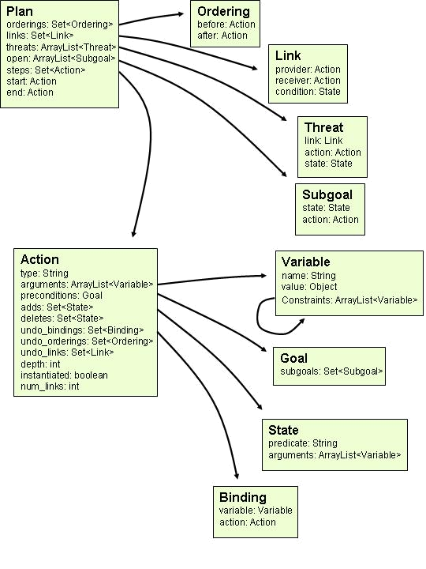

Figure 3.1: The important classes of the first version.

3.3 Binding Mechanism
Variables
An action has variables as arguments that represent the objects on which the action is performed. These same variables exist in the state descriptors within the action. Though there are really only as many variables as there are action arguments, these variables re-occur a number of times in the state descriptors. This implementation creates a separate Variable object for every occurrence of a variable, and sets the Variable names as they were represented in the action definition, so that instances with the same name represent the same conceptual variable.
The ‘start’ and ‘end’ Action objects are special actions with single sets of State objects (adds or precons respectively) and no arguments. Variables in these State objects are all bound, and they are bound directly to either a world object or Constant, as defined in the problem description.
For conventional actions, variables for the action operands are created first, and their names set (as, for example, x). Variables within the State sets are then created and are bound to the action operands of the same name, as shown in Figure 3.1. These bindings remain permanent, to enforce the concept that they are the same variable. Only the bindings of the action operands are manipulated during plan development.
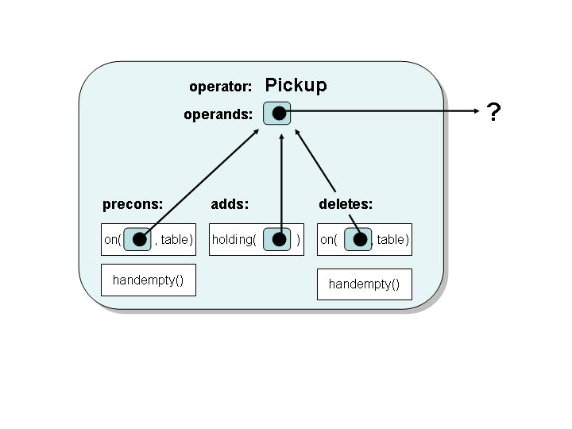

Figure 3.2: Variable binding within an action. State descriptor variables are bound to the action operands of the same name.
As a plan grows, one Variable can point to another, and this to another, much like a linked list. If the final Variable is bound to an Obj, all other Variables become bound to the object. To retrieve the binding of a Variable, a getRoot() method is included in the Variable object that iterates over the length of the pointers to return the terminal object.

Constants
Constants were specifically labelled objects within the ‘objects’ file, and instances were made of the Constant object upon intitialisation. Wherever a constant appeared in a state descriptor, these instances were searched for a match. If found, the Variable at that position in the state descriptor would be bound to that constant object. This binding would remain unchanged during plan development, and to prevent other variables from being bound to constants, the terminal object type was checked before any binding was done. Note: the Constant object is not portrayed in the class figure.
Instantiating actions
The binding of an action’s operands, e.g. the conversion of pickup(x) to pickup(apple), takes place when an action is recognized as a possible satisfier of a subgoal. After adding the action to the plan through the addition of Link and Ordering objects, the operands in the action need to be bound in such a way that the variables of the satisfying state descriptor in the adds set match those of the subgoal.
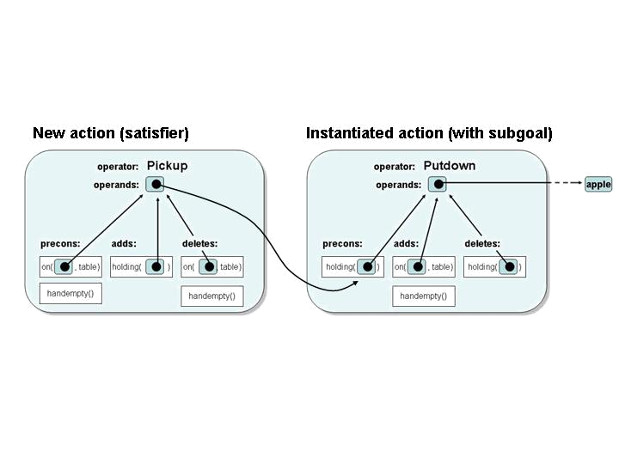
This is achieved through first identifying the state descriptor in adds that matches the subgoal. This test for equality will succeed where any unbound variables (there may be none) are bound to the same objects or the same constants.
The variables in the matching adds state descriptor are followed to the action operands, and these are bound to the variables in the subgoal in such a way that the satisfying state descriptor becomes bound identically to the subgoal. This is shown in Figure 3.3.

Figure 3.3: Binding during instantiation. When an action is instantiated to satisfy the subgoal holding(apple), the new action’s operand is bound to the variable in the subgoal.
Unbound instantiated actions
It is possible to instantiate an action without binding some or all of its operands. This occurs where the subgoal has no arguments, therefore requiring no binding for a state descriptor to match it. For example, pickup(apple) may require that the hand be empty first. This could be satisfied by an action putdown(x). The satisfying state descriptor handempty() matches the subgoal handempty() and so putdown(x) would then be instantiated, but unbound. This introduces the possibility of subgoals that have unbound variables.

Reverse binding
An unbound or partially bound subgoal may be satisfied by a previously instantiated action elsewhere in the plan with bound variables. Here, the usual process of binding a satisfying action to the subgoal variables can not occur. Instead, the unbound variables in the subgoal need binding to the satisfying action. This is a reverse of the usual process. The action containing the subgoal has its appropriate operands bound to the variables in the satisfying state descriptor, as shown in Figure 3.4.
Because of cases like this, it may also be possible to have bindings going from operands in both actions to State objects in the other.
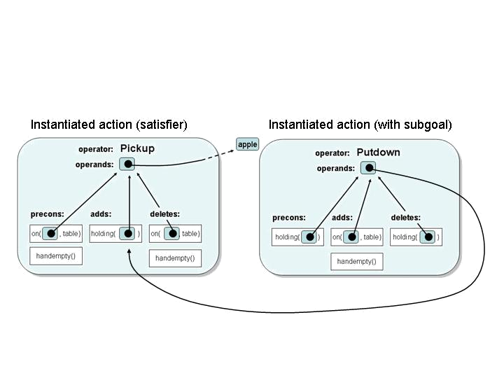

Figure 3.4: Reverse binding. If an action with a subgoal is unbound and an action with a satisfying state descriptor is bound, then the action with the subgoal needs to have its operands bound to the satisfying state descriptor.
3.4 Binding constraints
Implementation
Binding constraints are introduced into a plan through two ways. Some constraints are declared as part of a STRIPS operator description. For example, unstack(x, y) requires that x and y not be bound to the same object. These constraints are implemented when Action templates are created.
Binding constraints are also introduced during plan development through threat resolution. To prevent a possible threat from interfering with a link elsewhere in the plan, it is required that the Variables of the threatening State within a deletes not be bound in an identical manner to the Variables in the threatened subgoal.
Constraints are implemented as restrictions on a specific Variable instance. An array of the constrained variables is stored within a Variable object. Whenever that variable is to be bound, either directly or indirectly, the array is checked, the terminal bindings of those variables retrieved, and the object pending binding is compared to check for any matches. This requires checking constraints in all variables linked in a chain before binding the terminal variable.
Because constraints are implemented in Variable objects, a constraint included in an action definition has to have its vice-versa constraint placed in the other variable also, so that the constraint is recognized when either operand is bound.
When resolving a threat with a binding constraint, the constraint could be placed in the threatening State Variables, or the threatening Action’s operands. This implementation places constraints exclusively in action operands, as all State bindings are permanently connected to these Variables. This prevents every State object from requiring checking before binding an action operand.
Enforcement
Binding constraints are checked when a previously instantiated action is used to satisfy another subgoal. When the action operands are bound to the new subgoal, the set of constraints in the operands is checked for the impending binding. In the rarer case of the satisfied action operands needing binding to the satisfying state descriptor (reverse binding), constraints are checked in the operands of the action containing the subgoal.
Any constraints added through the threat resolution process will only appear in instantiated actions, not in new actions, therefore the above strategy suffices to check all constraints of that nature. However, constraints added as part of an action definition do occur in new actions. This implementation does not account for these, and therefore will produce errors where these constraints need enforcing.
3.5 Backtracking
Because a single plan is used in this implementation, backtracking is a process of undoing. This requires methods that can identify those portions of the plan that were contributors to the failed addition, and remove them without changing the rest of the plan. This is straightforward in instances where the modification was the addition or removal of an object from a set. Other undoings, such as the removing of instantiated actions, require more consideration.
Unlinking actions
A subgoal can either be satisfied by a newly instantiated action, or a previously instantiated action. If this creates an inconsistent plan, the action needs to be removed completely, in the former case, or unlinked from the appropriate subgoal, in the latter case. Determining the correct procedure is done using a num_links datafield in the Action object. This is incremented each time the action is used to satisfy a subgoal, and checked before removing/unlinking an action.
Removing a newly instantiated action is a relatively simple process, and simply requires locating and removing any links, orderings and open subgoals associated with the failed instantiation. These searches were shortened with the use of the undo_links and undo_orderings sets, which contained references to only those objects in the plan that involved the action.
Undoing a subgoal satisfaction by an action that was previously instantiated and satisfying other subgoals requires additional checks, to remove only those objects associated with the unsuccessful link. The undo sets can be used to identify objects that included both the actions involved in the failed link. However, variables also need to be unbound.
Unbinding variables
If the removed action was newly instantiated, no unbinding need occur, as the only bound pointers were within the failed action’s operands. These variables were bound to the subgoal, and nothing would have since been bound to the action.
Unlinking previously instantiated actions from a subgoal requires a check to identify which of the satisfying action’s operands are bound to the subgoal. The reverse also needs to occur – a check of any bindings of the operands in the action containing the subgoal to the satisfying state descriptor (in case of reverse binding).
However, Variable objects contain no information about the Action or State objects for which they are arguments. Therefore, selective unbinding requires the creation of a Binding object. This is a Variable/Action pair that identifies which other Action object an action’s operand is bound to. Binding objects are created after binding an operand, and placed within the undo_bindings set within the action. Selective unbinding then starts with a search through the set to establish which operands are connected to the Action involved in the failed link.
Unbinding is achieved by setting a Variable’s value to null.

3.6 Errors and Limitations
Binding/Unbinding
There were rare cases in the execution of this approach where configurations of variable bindings became very complex. Cases such as these would occur after a three step process as follows. Figure 3.5 on the following page gives a graphical example of the error.
- An action is instantiated to satisfy a subgoal that has no arguments (e.g. handempty()). The operands of this action are therefore unbound.
- This action introduces its own subgoals with unbound arguments. One of these is then satisfied by a second new action. Because the first action had unbound operands, the second does also, though the variables are linked in the subgoal satisfaction.
- A third action elsewhere may have a subgoal that can be satisfied by the second action. It recognizes a satisfying state in the action, and notes that the variables are unbound. It therefore binds the operands of the action to its own subgoal, breaking the binding between the first and second actions.

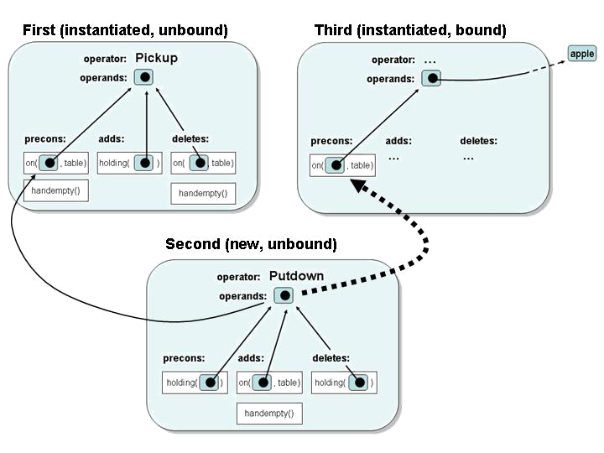

Figure 3.5: A binding error. The third action has its subgoal satisfied by the second action, indicated by the large dotted arrow. This binding occurs because the second’s operands appeared unbound. However, this binding breaks the existing binding of the second action to the first.

Solutions to this problem would lie in recognizing the second action’s operands as bound to other unbound variables. The operands in the first action could then be bound to the third action’s subgoal. This is feasible, but methods then need to be written that undo this binding. At this point it was decided that an alternative binding technique was required.

Chapter 4
Implementation 2
4.1 Why a second implementation was created
Due to the exploratory nature of the first attempt, amendments to the code were added in an ad-hoc manner. The structure of the program would require extensive tidying if it would ever be presentable as a teaching tool. It was decided that the creation a second version, with a clear initial concept gained from experience with the first, would produce a more concisely written program.
Implementing Variables as pointers created unpredicted complexity, as mentioned in Chapter 3, and this was exacerbated by the need for undoing. Implementing the partial-order-planner algorithm in a way that created new plans where any additions were made would avoid the need for undoing. An implementation of this kind would be more compact and more bug-free in the absence of undoing methods.
The first version was only able to perform a depth-first search through the plan-space. An approach that developed many plans in parallel could be adjusted to perform any kind of tree-traversal desired. Breadth-first-search may prove to be a more efficient method for partial-order-planning.
4.2 Approach
Many plan objects
The key difference in the second approach is in the development of a number of plans in parallel. There are two places in the plan-space where new plans are created: satisfying subgoals and threat resolution. Each of these corresponds to an OR choice, i.e. a solution will only contain one of the options. When reaching this point in the algorithm, each option is attempted, with a number of ‘sibling’ plans created for every branch.
Iterative
Replacing the recursive method in the first implementation is a loop. At the beginning of the loop a plan is removed from the head of the queue. The plan is checked for completeness and if complete (no open subgoals) the loop breaks and the solution is returned. Otherwise subgoal-satisfaction and threat-resolution are attempted, resulting in the addition of more plans to the queue.
Plans described with linked lists
Creating and queuing new plans for every OR branch can quickly exhaust memory. During each iteration, a single plan is often replaced by tens of others, where every threat will result in one, two or three possible solutions. It is therefore crucial to shallow-copy, but in a way that prevents altering one plan from affecting its siblings and their successors. This was done through the use of linked lists. A plan is represented as a group of linked lists, containing the actions, orderings, links, bindings, constraints, subgoals and threats. Making a shallow copy of a plan is done by copying the pointers to the first elements in these lists. If these copies are then modified, the new elements are inserted above the other elements, where they are inaccessible to ancestors, and siblings and their successors.
No undoing
Backtracking in this implementation does not require removing elements from a list. A failed plan is simply discarded. Discarding a plan also discards any references to the additions to the list specific to that plan, so these additions are cleaned up by the Java Garbage Collector. The older portion of the list will still make up the contents of other parallel plans, and will remain.
4.3 Classes
On the following page is a figure of the main classes used in the second version. Again, only a few of the relationships between objects have been represented with arrows. The key differences in the classes from those of the previous version are outlined below. Reasons for, and effects of, the changes will be discussed in the remainder of this chapter.
Action
The Action object no longer has any undo fields.
Variable
The Variable object does not have a pointer (a value field). Nor does it have a set of constrained variables. In this version, the Variable is little more than uniquely identifiable Java objects. Constants are also implemented using the same Variable object, with a flag defining one type from the other.
Binding
A Binding is no longer an object used for the unbinding of an action’s operands as in the previous version. Here, it is a Variable/Object pair used to implement variable binding. This object replaces the need for variable pointers.
Constraint
Constraints are implemented with a new object that contains references to the two constrained Variables. This replaces the set of constrained variables within the Variable class.
Plan
The Plan object is entirely represented using Linked Lists. This is because of the requirement of this approach of making shallow copies of Plan objects. Bindings and constraints are now included in the Plan description. The ‘start’ and ‘end’ actions have been incorporated into the set of steps.
No Goal object
The goal object was removed as it didn’t offer convenience or functionality.

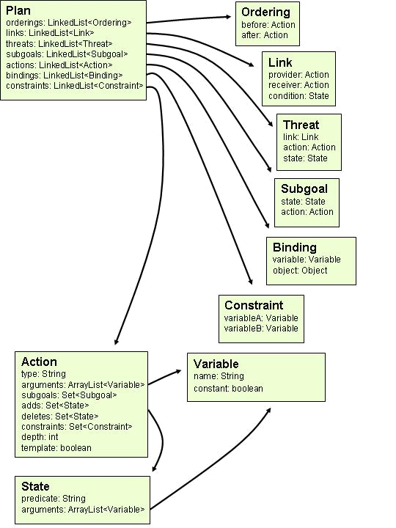

Figure 4.1: The important classes of the second implementation.

4.3 Binding Mechanism
One Variable object per operand
The first implementation created a new Variable instance for every occurrence of a variable in an action’s state descriptors. However, these programs assume that all variables in the state descriptors occur in the action operands also. This implementation created a single Variable instance for each operand, and all state descriptors used these same instances as their arguments.
Variable/Object pairs
This approach requires that plans be entirely defined with linked lists. Having variables contain pointers is therefore not possible, as altering these pointers in one plan will alter the pointers of those same Variable instances in other plans. Instead, binding is achieved through placing a reference to a variable into a pair with another reference to either a variable or a world object. These pairs can then be stored as objects in linked lists that can be extended in one plan without affecting others. Methods that retrieve the terminal objects have to traverse the list, possibly a number of times for chains of bindings.
Access to operands via state descriptors
Because of the use of shared Variable instances, binding a satisfying state descriptor to a subgoal can be performed without requiring a view of their containing actions. The two state descriptors can simply have their variables paired, and this also directly binds the corresponding action operands and other corresponding state descriptor arguments.
Variable/Object binding
Most often, the subgoal variables will be bound to world objects and the satisfying state descriptor will have unbound variables. These variables will then be paired in an identical manner to the subgoal Variables, to the same world objects. This is preferable over binding to the subgoal Variables because it minimises distances to terminal objects, and reduces the probability of circular binding.
Variable/Variable binding
In cases where the subgoal variables are also unbound, variables must be paired together. Binding variables to variables immediately introduces the risk of circular bindings, which would cause the algorithm to loop infinitely when trying to retrieve a terminal object. Circular bindings are avoided by checking the plan’s set of bindings for the reverse of the current binding. This check needs to recognize chained bindings also. If found, the new binding does not have to be added.
Constants
Where an English word appears in the arguments of a state descriptor, this is assumed to be a constant, and a new Variable instance is created that then has its constant flag set to true. A constant is considered to be a static part of the definition of a state descriptor, and so no variables are bound to other variable objects labelled as constants.

4.4 Binding constraints
Implementation
Binding constraints that occur as part of an action definition are placed in the new Action objects. When these actions are instantiated into a plan, constraints are copied from the action into a linked list within the plan. Binding constraints that are created through threat resolution are appended directly to this list.
Enforcement
The implementation does not check the constraints when binding variables. Instead, the check occurs within the method used to return a plan’s consistency (using the topological sort). The check is simple, and simply involves iterating down the linked list of constraints, and for each pair of variables, checking the plan’s set of bindings to see if they are bound to the same object. If so, the plan is inconsistent and will be discarded.
4.5 Errors and Limitations
Memory
The implementation will still reach memory limits for very large problems. Even though the large number of plans refer to the same set of seven linked lists, the small amount of space needed to store each plan object can add up. The first implementation will never require more memory than that required by a single plan, so long searches don’t run the same risk.
Debugging
Due to the regular switching of plans, the algorithm becomes very difficult to debug. If an issue requires fixing, explicit code is often required to check for the conditions that lead to the fault. Debugging is therefore usually a process of trial-and-error. In comparison, the first implementation could output a clear record of its execution.
Circular bindings
The program currently, in rare cases, encounters a circular binding problem, where the attempt to return a terminal binding quickly reaches an out-of-stack-memory error. The cause of this problem has not been determined.
Chapter 5
Evaluation
The following sections describe a variety of domains and tasks on which both programs were tested
5.1 Briefcase World
The Briefcase world is the one described in the original UCPOP paper. It contains a briefcase that can be moved between locations. Objects can be put inside and taken from the briefcase. Tasks involve moving objects from one location to another. (See Appendix 1 for more details.)
Actions and Objects of the Briefcase domain
Actions | Description
move-briefcase(x, y) | If the briefcase is at x, it is moved to y.
take-out(x, y) | If x is in the briefcase and the briefcase is at y, x is taken from the briefcase and is then at location y.
put-in(x, y) | If x and the briefcase are at y, x is put in the briefcase and is no longer at y.
Objects
office
home
dictionary
paycheck

Task
The dictionary and the briefcase are at home, with the paycheck in the briefcase. The dictionary needs to be taken to the office, and the paycheck taken home. This is the problem used as an example in the UCPOP paper.
Initial state
at(briefcase, home)
at(dictionary, home)
in(paycheck, briefcase)
Goal state
at(dictionary, office)
at(paycheck, home)

Version 1 output
Add_counter: 28
Next action: start()
Next action: put-in(dictionary, home, )
Next action: take-out(paycheck, home, )
Next action: move-briefcase(home, v58, )
Next action: move-briefcase(v58, office, )
Next action: take-out(dictionary, office, )
Next action: end()
Time taken in milliseconds: 65

Version 2 output
Next action: start()
Next action: put-in(dictionary, home, )
Next action: take-out(paycheck, home, )
Next action: move-briefcase(home, office, )
Next action: take-out(dictionary, office, )
Next action: end()
SOLVED at depth 2
Time taken in milliseconds: 114

Interpretation
Both versions solve this task, creating valid plans. This first version puts the dictionary in the briefcase while at home, and takes out the paycheck before moving the briefcase. It has used two move-briefcase actions instead of one, but this breaks no rules within the problem domain as we have not stated that all variables within an action need to be bound. This restriction could be worked into the program to avoid creating plans in this manner. After moving the briefcase to the office, the dictionary is removed.
The second version reaches the same plan, though with the single move-briefcase action. It takes approximately twice as long though both times were short. Subgoal satisfaction, variable binding, and threat resolution have all been conducted without error in both implementations.
5.2 Cook world
This world was written specifically for this report, and includes a larger selection of actions than the briefcase world, though the nature of the actions are fairly deterministic, i.e. it is rare for more than one action to be a possible subgoal satisfier. This increases the depth of the required plan-space but reduces its width. It describes cooking and eating food items using a pot, water and a stove (See Appendix 2 for more details.)

Actions and objects of the Cook domain
Actions | Description
turn-stove-on() | If the stove is off, it is turned on
turn-stove-off() | If the stove is on, it is turned off
put-on-stove(x) | If x if off the stove, it is put on the stove
add-water(x) | If x is on the stove and empty, water is added to x
boil-water(x) | If there is water in x and the stove is on, the water is boiled
add(x, y) | If there is boiling water in x and x is on the stove, y is put in x
cook(x, y) | If y is in x and x is on the stove, y is cooked
eat(x) | If x is cooked, x is eaten
Objects
pot
rice
broccoli

Task
Rice and broccoli need to be cooked and eaten.
Initial state
off-stove(pot)
empty(pot)
stove-off()
uncooked(rice)
uncooked(broccoli)
Goal state
eaten(rice)
eaten(broccoli)

Version 1 output

Could not find a solution.

Version 2 output

Interpretation
Next action: start()
Next action: turn-stove-on()
Next action: put-on-stove(pot, )
Next action: add-water(pot, )
Next action: boil-water(pot, )
Next action: add(pot, broccoli, )
Next action: cook(pot, broccoli, )
Next action: eat(broccoli, )
Next action: add(pot, rice, )
Next action: cook(pot, rice, )
Next action: eat(rice, )
Next action: end()
SOLVED at depth 6
Time taken in milliseconds: 62
It is unknown why the first version fails on this problem, though it terminates explicitly after a failed search, indicating it did not identify a satisfying action to some subgoal.
The second version produces a correct plan in a short time, reaching an action-depth of six in its iterative-deepening search. This result indicates that the implementation’s variable binding and subgoal satisfaction worked well. Threat detection and resolution are not thoroughly tested here, because few actions delete conditions from the world, other than cook(x, y) deleting uncooked(y), and turning the stove on and off.
5.3 Blocks World
This world is well known in planning, and contains a number of blocks that can be placed on a table or on one another. A single arm, which can hold one block at a time, manipulates these blocks. The fact that blocks can be lifted and put down means there are many opportunities for infinitely repeating sequences of actions. Subgoals can usually be satisfied by more than one kind of action so the plan spaces in this problem domain are wide. (See Appendix 3 for more details.)

Actions and Objects of Block World
Objects
BlockA
BlockB
BlockC

Actions | Description
Unstack(x, y) | If the arm is empty, x is on y, and x is clear, takes y off x
Stack(x, y) | If x is held and y is clear, places x on y
Pickup(x) | If x is on the table and clear, picks up x
Putdown(x) | If x is held, places x on the table
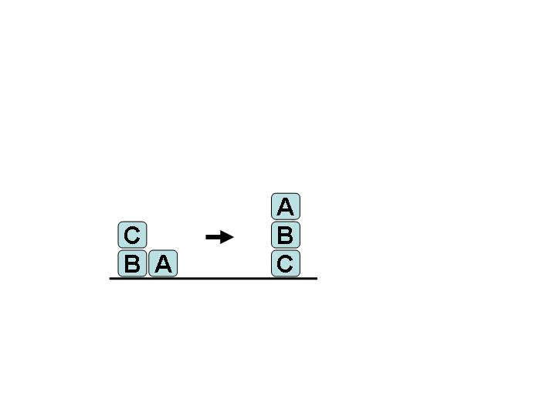
Task A
BlockA and blockB are on the table. BlockC is on blockB.
BlockA needs to be stacked on blockB and blockB on blockC.

Goal state
on(blockA, blockB)
on(blockB, blockC)
Initial state:
armempty()
on(blockB, table)
on(blockA, table)
on(blockC, blockB)
clear(blockA)
clear(blockC)

Version 1 output
Next action: start()
Next action: Unstack(blockC, blockB, )
Next action: Putdown(blockC, )
Next action: Pickup(blockB, )
Next action: Stack(blockB, blockC, )
Next action: Pickup(blockA, )
Next action: Stack(blockA, blockB, )
Next action: end()
Time taken in milliseconds: 5140

Version 2 output
Next action: start()
Next action: Unstack(blockC, blockB, )
Next action: Putdown(blockC, )
Next action: Pickup(blockB, )
Next action: Stack(blockB, blockC, )
Next action: Pickup(blockA, )
Next action: Stack(blockA, blockB, )
Next action: end()
SOLVED at depth 3
Time taken in milliseconds: 2687

Interpretation:
Both implementations generate good plans. The second version takes half the time of the first. This problem demonstrates the successful execution of binding, subgoal satisfaction, and threat detection and resolution in both implementations.
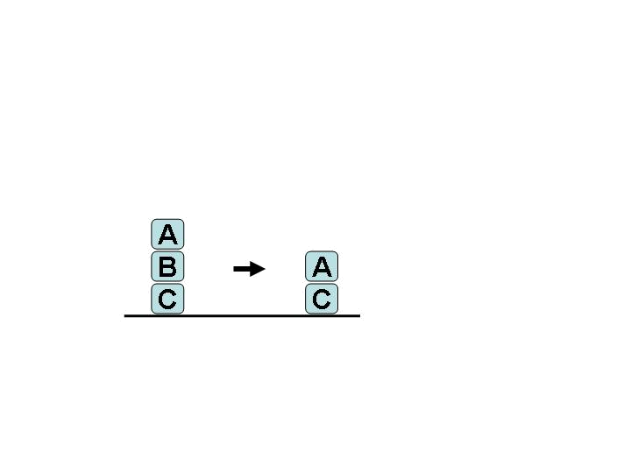
Task B
BlockA is on blockB and blockB is on blockC.
BlockA needs to be stacked on blockC.

Initial state
ae
on blockA blockB
on blockB blockC
on blockC table
clear blockA
Goal state
on blockA blockC

Version 1 output
Next action: start()
Next action: Unstack(blockA, blockB, )
Next action: Putdown(blockA, )
Next action: Unstack(blockB, blockC, )
Next action: Putdown(blockB, )
Next action: Unstack(blockA, blockB, )
Next action: Stack(blockA, blockC, )
Next action: end()
Time taken in milliseconds: 2145985

Version 2 output
Next action: start()
Next action: Unstack(blockA, blockB, )
Next action: Unstack(blockB, blockC, )
Next action: Stack(blockA, blockC, )
Next action: end()
SOLVED at depth 5
Time taken in milliseconds: 338140

Interpretation
The first version took approximately 35 minutes where the second took just under six. The first version’s plan is almost correct, aside from using Unstack(blockA, blockB) in the second-to-last action instead of Pickup(blockA). The Unstack action probably has its subgoal of on(blockA, blockB) satisfied by the start() action, though the threat of the other Unstack(blockA, blockB) action (which deletes this condition) was undetected/unresolved.
The plan of the second version is valid if two objects could be held at once. This again suggests a failure in threat detection/resolution. The second Unstack can only have had its handempty() precondition satisfied by the start() action. The first Unstack deletes this condition, though it occurs between the two actions in the link.
5.4 Fridge World
This world was one of many domains distributed with the original UCPOP code. It has another fairly deterministic set of actions. It describes unscrewing screws to remove of the back panel of a fridge to swap out a broken compressor. (See Appendix 4 for more details.)
Actions and Objects of the Fridge domain
Objects
screw1
screw2
screw3
screw4
backplane
compressor1
compressor2
fridge
Actions | Description
unscrew(x, y) | If x and y are held and x is screwed, x is unscrewed
screw(x, y) | If x and y are held and x is unscrewed, x is screwed
remove-backplane(x,f,a,b,c,d) | If x is in-place and part of f, and f is off, and a, b, c and d are all held and unscrewed, x becomes not-in-place
attach-backplane(x,f,a,b,c,d) | If x is not-in-place and part of f, and f is off, and a, b, c and d are all held and unscrewed, x becomes in-place
start-fridge(x,f,a,b,c,d) | If x is in-place and part of f, and f is off, and a, b, c and d are all held and screwed, x becomes in-place
stop-fridge(f) | If f is on, f is turned off
change-compressor(x,y,a) | If x is attached and y is detached, and a covers x and is not-in-place, x becomes detached, y becomes attached, and a covers y
Task
The fridge needs to be turned off before unscrewing four screws, removing the back panel, and changing the compressor.
Initial state
covers(backplane, compressor1)
part-of(backplane, fridge)
holds(screw1, backplane)
holds(screw2, backplane)
holds(screw3, backplane)
holds(screw4, backplane)
detached(compressor2)
ok(compressor1)
ok(compressor2)
fridge-on(fridge)
screwed(screw1)
screwed(screw2)
screwed(screw3)
screwed(screw4)
in-place(backplane)
attached(compressor1)
Goal state
attached(compressor2)
ok(compressor2)
Version 1 output
Next action: start()
Next action: stop-fridge(fridge, )
Next action: unscrew(screw4, backplane, )
Next action: remove-backplane(backplane, fridge, screw4, screw4, screw4, screw4, )
Next action: change-compressor(compressor1, compressor2, backplane, )
Next action: end()
Time taken in milliseconds: 16

Version 2 output
Next action: start()
Next action: unscrew(screw1, backplane, )
Next action: stop-fridge(fridge, )
Next action: remove-backplane(backplane, fridge, screw1, screw1, screw1, screw1, )
Next action: change-compressor(compressor1, compressor2, backplane, )
Next action: end()
SOLVED at depth 5
Time taken in milliseconds: 391
Interpretation
Constraints were not included in the action definitions to prevent the same screw object being bound four times in the same action. Both versions therefore used the condition of holding a single screw to satisfy the preconditions of holding four screws. These plans are correct in that they break no defined rules of the world. Adding the constraints necessary to prevent this caused both versions to fail. Both versions completed this task in short time, though the second version’s time was approximately 20 times that of the first.
5.5 Monkey World
This domain describes a world where a monkey moves objects to the location of a hanging bunch of bananas, where he can then climb the object to reach the bananas. It has a wide plan-space and many opportunities for circular actions. (See Appendix 5 for more details.)
Actions and objects of the Monkey domain
Actions | Description
move(x, y) | If the monkey is on the floor and at x, the monkey moves to y.
push(x, y, z) | If the monkey and z are on the floor and at x, the monkey and z move to y.
climb(x, y) | If the monkey and x are at y, and they are both on the floor, the monkey becomes on x.
grasp(x, y) | If the monkey and x are at y, and the monkey is not on the floor, the monkey holds x.
Objects
chair
box
bananas

Task
The monkey needs to move one of two objects from either the window or the corner of the room to the same location as the hanging bananas, the centre of the room. It then needs to climb the object and grasp the bananas.
Initial State
at monkey door
at chair corner
at box window
at bananas center
on-floor monkey
on-floor chair
on-floor box
Goal state
holding monkey bananas

Version 1 output
Next action: start()
Next action: move(door, center, )
Next action: climb(chair, corner, )
Next action: grasp(bananas, center, )
Next action: end()
Time taken in milliseconds: 110

Version 2 output
Next action: start()
Next action: move(door, corner, )
Next action: move(corner, center, )
Next action: climb(chair, corner, )
Next action: grasp(bananas, center, )
Next action: end()
SOLVED at depth 3
Time taken in milliseconds: 2031

Interpretation:
Both versions fail at this task. Interestingly, neither implementation executed a push action. When attempting to have either version conduct a push (by changing the goal state to at(center, box)) they both fail also. The syntax of the input files appears to be correct, so the problem is unknown. Both versions return plans that don’t recognize the need for the climbed object to be under the bananas. The grasp action, however, implies this, as it requires the monkey be off the ground and at the same location as the bananas. The second required around two seconds where the first required a tenth of a second.

Chapter 6
Conclusion
Goals reached
A cleanly structured Java implementation was created
The second version is a cleanly structured and presentable implementation. It provides an accessible structure to which modifications and heuristics can be added. The clear layout of the code allows a viewer to see the algorithm in a way that will aid them in understanding the various steps and how they work together.
The first implementation can be used to print out the steps taken by the algorithm and this is an excellent way of demonstrating the planning technique to students. The code has been designed to make the detail of the output easily changeable, so that intricate details can be omitted for simplification or included for complete understanding.
The planner was not integrated with another conventional planner
Due to the unexpected difficulty in completing the implementations, the algorithm was never integrated with the goal hierarchy system or tested in an actual robot. This procedure could be completed in the future if an implementation is perfected.
Neither planner performed perfectly
Neither version performs fault-free. Bugs in the first implementations seem to be within its threat identification/resolution methods, though all parts of the algorithm effect others so pinpointing is difficult. The difficulty is compounded by the fact that errors usually only arise in more complex problems, and the output during these executions is very long and impractical to examine manually.
The second implementation performs more reliably than the first, which reflects its cleaner and more concise approach. Errors also usually occur on lengthy executions, and the output of this version is very difficult to follow.
Neither method appeared to perform consistently faster then the other.
Both implementations function well enough to make them useable tools for demonstrating the algorithm.
Future Work
Applying heuristics
These implementations did not reach the point where efficiency gains were attempted through the addition of heuristics. On some tasks the algorithms have run for hours or days. This obviously reduces their usefulness in real-world applications. However, these programs (particularly the last) will allow the easy insertion of any of the heurists mentioned in Chapter 2. The appropriate places for insertion in the code are easy to recognize; it is simply a matter of expanding the required method. This remains as a task for future developers.
Bibliography
[1] J. S. Penberthy, D. S. Weld. UCPOP: A Sound, Complete, Partial Order Planner for ADL. In Proc. of the Third International Conference on Principles of Knowledge Representation and Reasoning, pp. 103-114, 1992.

[2] S. Kambhampti. Design Tradeoffs in Partial Order (Plan Space) Planning. In Proc. International Conference on AI Planning Systems. May 1994.

[3] X. Nguyen, S. Kambhampati. Reviving Partial Order Planning. In Proc. of the Seventeenth International Joint Conference on Artificial Intelligence, pp. 459-464, 2001.

[4] M. A. Peot, D. E. Smith. Threat Removal Strategies for Partial-Order Planning. In Proc. of the Eleventh National Conference in AI (AAAI-93), 1993.

[5] D. E. Smith, M. A. Peot. Postponing Threats in Partial-Order Planning. In Proc. of the Eleventh National Conference in AI (AAAI-93), 1993.

Appendix 1: Briefcase world
Format for actions:
<Operator>
<Operands>
<Preconditions> (seperated by ',')
<Deletes> (seperated by ',')
<Adds> (seperated by ',')
<Constraints> (pairs of operands seperated by whitespace)

Format for state descriptors:
<predicate> <arguments> (seperated by whitespace)

move-briefcase
?m ?l
at briefcase ?m
at briefcase ?m
at briefcase ?l
?m ?l

take-out
?x ?y
at briefcase ?y, in ?x briefcase
in ?x briefcase
at ?x ?y

put-in
?x ?y
at ?x ?y, at briefcase ?y
at ?x ?y
in ?x briefcase
Appendix 2: Cook World
Format for actions:
<Operator>
<Operands>
<Preconditions> (seperated by ',')
<Deletes> (seperated by ',')
<Adds> (seperated by ',')
<Constraints> (pairs of operands seperated by whitespace)

Format for state descriptors:
<predicate> <arguments> (seperated by whitespace)

add-water
?x
on-stove ?x, empty ?x
empty ?x
waterAdded ?x

boil-water
?x
stove-on, waterAdded ?x

waterBoiling

add
?x ?y
waterBoiling, on-stove ?x

in ?x ?y

cook
?x ?y
in ?x ?y, stove-on
uncooked ?y
cooked ?y

eat
?x
cooked ?x

eaten ?x

turn-stove-on

stove-off
stove-off
stove-on

turn-stove-off

stove-on
stove-on
stove-off

put-on-stove
?x
off-stove ?x
off-stove ?x
on-stove ?x
Appendix 3: Blocks World
Format for actions:
<Operator>
<Operands>
<Preconditions> (seperated by ',')
<Deletes> (seperated by ',')
<Adds> (seperated by ',')
<Constraints> (pairs of operands seperated by whitespace)

Format for state descriptors:
<predicate> <arguments> (seperated by whitespace)

Unstack
?x ?y
on ?x ?y, ae
on ?x ?y, ae
holding ?x, clear ?y

Pickup
?x
on ?x table, clear ?x, ae
on ?x table, ae
holding ?x

Putdown
?x
holding ?x
holding ?x
on ?x table, ae

Stack
?x ?y
holding ?x, clear ?y
holding ?x, clear ?y
on ?x ?y, ae
?x ?y
Appendix 4: Fridge World
Format for actions:
<Operator>
<Operands>
<Preconditions> (seperated by ',')
<Deletes> (seperated by ',')
<Adds> (seperated by ',')
<Constraints> (pairs of operands seperated by whitespace)

Format for state descriptors:
<predicate> <arguments> (seperated by whitespace)

unscrew
?x ?y
screwed ?x, holds ?x ?y
screwed ?x
unscrewed ?x

screw
?x ?y
unscrewed ?x, holds ?x ?y
screwed ?x
unscrewed ?x

remove-backplane
?x ?f ?a ?b ?c ?d
in-place ?x, part-of ?x ?f, fridge-off ?f, holds ?a ?x, holds ?b ?x, holds ?c ?x, holds ?d ?x, unscrewed ?a, unscrewed ?b, unscrewed ?c, unscrewed ?d
in-place ?x
not-in-place ?x

attach-backplane
?x ?f ?a ?b ?c ?d
not-in-place ?x, part-of ?x ?f, fridge-off ?f, holds ?a ?x, holds ?b ?x, holds ?c ?x, holds ?d ?x, unscrewed ?a, unscrewed ?b, unscrewed ?c, unscrewed ?d
not-in-place ?x
in-place ?x

start-fridge
?x ?f ?a ?b ?c ?d
in-place ?x, part-of ?x ?f, fridge-off ?f, holds ?a ?x, holds ?b ?x, holds ?c ?x, holds ?d ?x, screwed ?a, screwed ?b, screwed ?c, screwed ?d
fridge-off ?f
fridge-on ?f

stop-fridge
?f
fridge-on ?f
fridge-on ?f
fridge-off ?f

change-compressor
?x ?y ?a
not-in-place ?a, covers ?a ?x, attached ?x, detached ?y
attached ?x, detached ?y, covers ?a ?x
detached ?x, attached ?y, covers ?a ?y
Appendix 5: Monkey World
Format for actions:
<Operator>
<Operands>
<Preconditions> (seperated by ',')
<Deletes> (seperated by ',')
<Adds> (seperated by ',')
<Constraints> (pairs of operands seperated by whitespace)

Format for state descriptors:
<predicate> <arguments> (seperated by whitespace)

move
?x ?y
at monkey ?x, on-floor monkey
at monkey ?x
at monkey ?y

push
?x ?y ?z
at monkey ?x, at ?z ?x, on-floor monkey, on-floor ?z
at monkey ?x, at ?z ?x
at monkey ?y, at ?z ?y

climb
?x ?y
at monkey ?y, at ?x ?y, on-floor monkey, on-floor ?x
on-floor monkey
on monkey ?x, not-on-floor monkey

grasp
?x ?y
at monkey ?y, at ?x ?y, not-on-floor monkey
at ?x ?y
holding monkey ?x

